Software Project Management Plan

- Problem Statement
- To create a game that tests the memory of the player. There will be a persistence component that will keep track of users and their high scores. This project will run on any device that supports a java web application or android application.
- Project Organization
- This Project was organized using the Waterfall Method and followed the following categories:
  - Requirements Elicitation
  - Analysis
  - System Design
  - Object Design
  - Implementation
  - Testing
- Project Milestones and Objectives
  - Work Breakdown Structures
    - PERT Chart
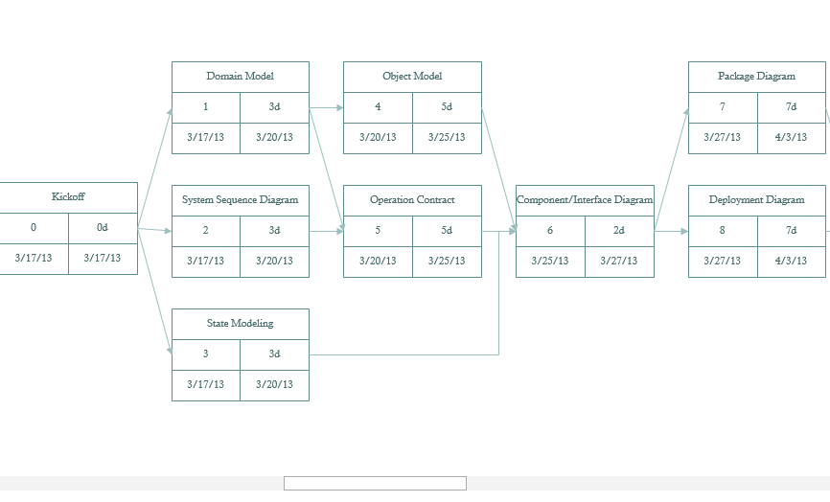

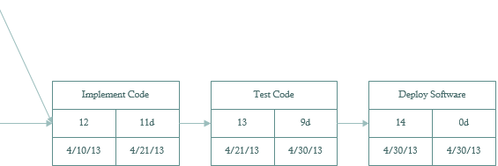
  - Roles/activities/people

    - Project Leader: William Holder
    - Documentation: William Holder, Jason Purcell, Timothy Sullivan, Hao Wu
    - Secretary/ Meeting Journals: Jason Purcell
    - Programming
      - Android
        - GUI Builds: William Holder, Patrick Poirson, Timothy Sullivan
        - Programming: William Holder, Patrick Poirson, Timothy Sullivan
      - Java Applet
        - GUI Builds: Jason Purcell
        - Programming: William Holder, Patrick Poirson, Jason Purcell, Timothy Sullivan
      - Quality Assurance: Timothy Sullivan
      - Testing: Timothy Sullivan

  - Schedule(estimated vs Actual)
    - Estimated
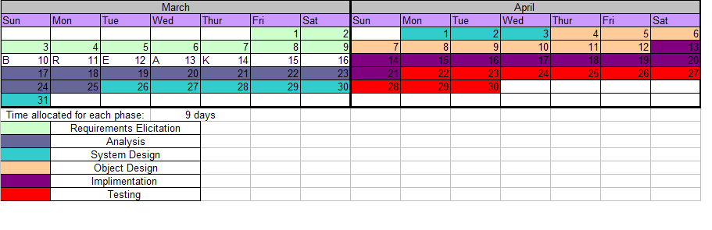

    - Actual
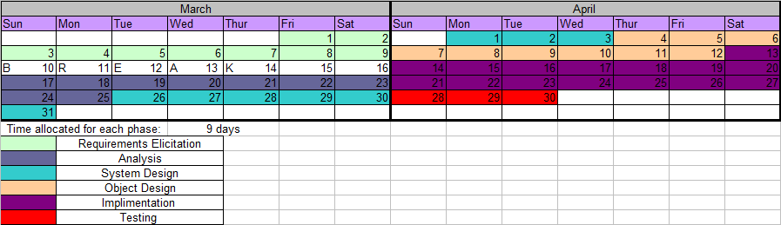
- Risk Management Plan
  - Risks that were encountered during the project
    - Time constraints on participants- had other class assignments or obligations to attend to.
    - Meetings – some participants were unable to attend all meetings due to diverse schedules.
    - Family Emergencies
- Configuration Management Plan
  - Majority of Configuration Management was controlled via Quality Control.
  - Documents went into the project file system (Sakai/ Github) in which QC would evaluate documentation. The documents were rejected or approved as needed.
- Deployment Plan
  - Android Tablet
  - Java Web Application
- Quality Management Plan
  - Quality Management was assigned to Timothy Sullivan. Files were placed in the project file system for approval/ rejection.
- Documentation Plan
  - Documentation was assigned and distributed between all group member in this project.
  - All documentation was uploaded to Sakai or Github for evaluations and/or approval.

- Testing Strategy
  - J-Unit testing was the default testing method used and code went through testing as it was being developed.
- Environment Description
  - Java Eclipse
    - Java SDK
    - Android SDK
- Lessons Learned
  - Organization is essential in managing a project and its success.
  - Communication is very important and also very difficult.
  - Introduction back into software languages and introduction of new software components can prove challenging.

